Update to Exercise 2 Solutions
Tom McGrath

I wasn't happy with the previous number of results I got for exercise 2 – time constraints during the week meant that I couldn't run the calculations as comprehensively as I'd have liked. To get better results, I recompiled on my personal computer using the icc -O3 flag and processor-specific compilation targeting -xSSE4.2. I'm running a 2nd-generation Core i7 Q720, so this is the most recent processor-specific optimisation I can support. I've attached results below. The code is the same.

1D case:

SOR:
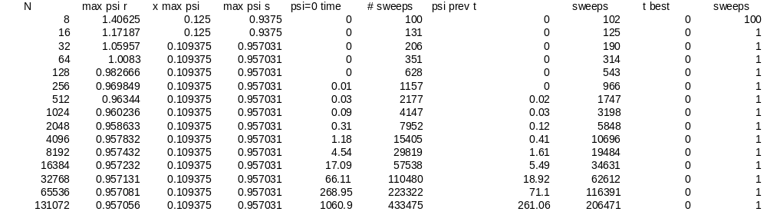
Parallelised:
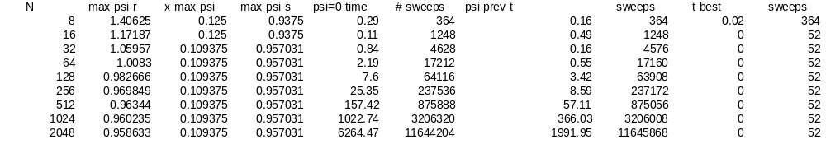
When I set omega not equal to 1 in the 1D or 3D case, the algorithm does not converge – in 1D it goes to zero and in 3D it goes to -inf. I've had a try at debugging and still can't figure out why exactly, but it appears that the red-black update procedure causes 'ripples' in psi (neighbouring values, which become magnified very fast.

2D:
Gauss-Seidel:
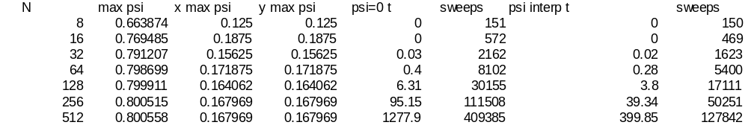
SOR:
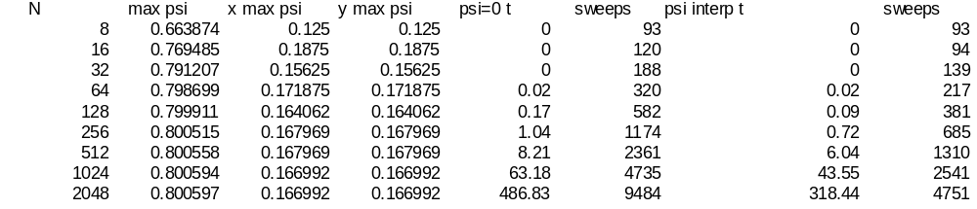
Red-black SOR in parallel:
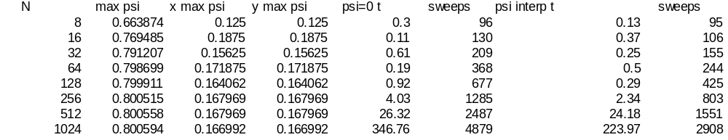
There's 2 notes regarding the parallel values:
- The time recorded is wrong – I timed it and the N=1024 computation takes approximately 90 seconds wall clock time. I've only observed this effect on parallel computations.
- Running 8 cores at 100% causes a laptop to overheat very fast! Even sitting outside in the cold didn't help, the computer overheated and shut down before I could reach N=2048. Now I see why datacenters are built in places like Iceland.

